Result on Question 1

1. Solution

Based on the knowledge that the goals in soccer is Poisson distributed, first the goals difference for three cases like win, loss and draw were extracted and reversed by opposite value.

And then, the histograms for each case were plotted by hist() function in R as following.

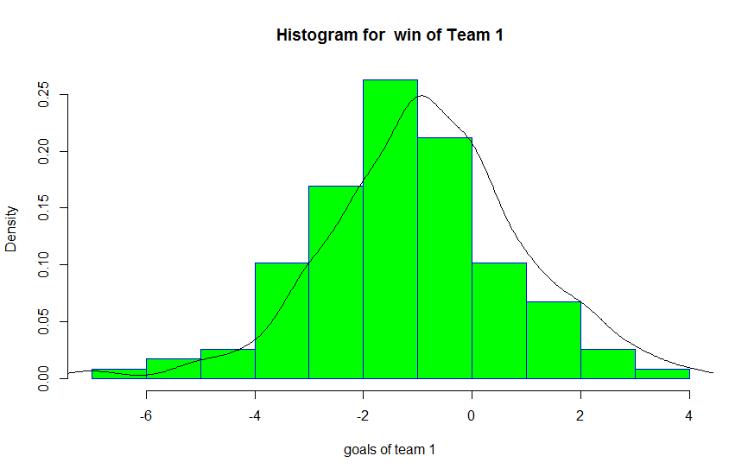

Fig 1. Histogram for goal difference in condition of Team1’s win for first game

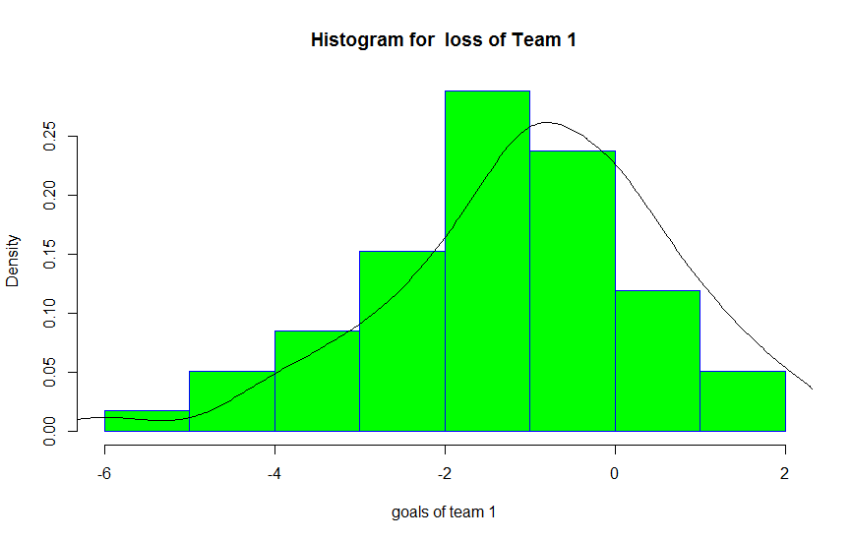

Fig 2. Histogram for goal difference in condition of Team1’s loss for first game

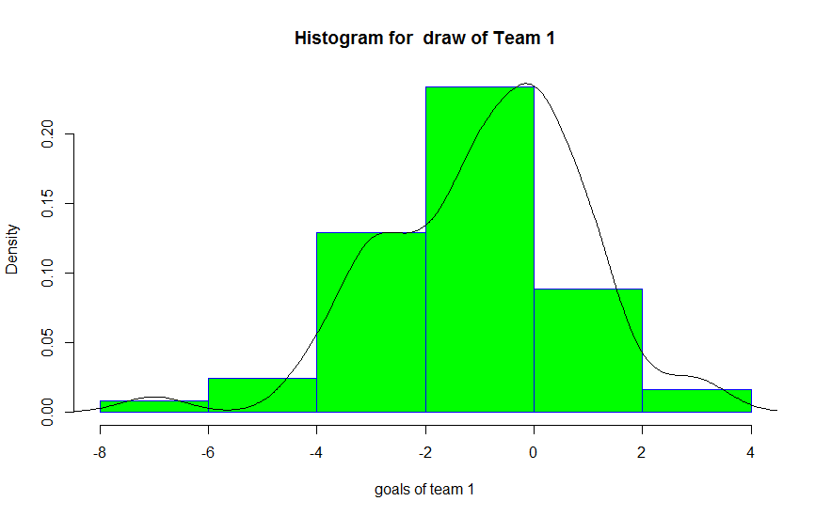

Fig 1. Histogram for goal difference in condition of Team1’s draw for first game

As known from the above figures, the goal difference of second games is Poisson distributed.

And the confidence interval based on confidence level has been calculated by quantile() function in R.

Table 1. 95% Confidence interval of goal difference of second game

|  |  |
| --- | --- |
| Team 1 | |
| Result Game 1 | Confidence Interval |
| Won | [-3.1, 2.0] |
| Draw | [-4.00, 1.05] |
| Lost | [-3.9, 1.0] |

1. Conclusion

From the graphs, table to be outputted, we can be sure that the goal difference of soccer match is poisson distributed.

Fig.1 shows that the probability of win of the second game for Team 1 that won in the first game is lower rather than one of Team 2. It means the strength of all the members of team 1 were downgraded because of over-playing in their home grounds in order to win.